Key Points
- There are no alternatives to diesel powered equipment for the vast majority of MPA members and we do not expect there to be soon
- There will be no environmental benefit as our industry will continue to use diesel until effective and efficient alternatives have been developed
- There will be a hit to confidence and potentially investment in difficult economic circumstances, with companies considering slowing their equipment renewal rate in response until alternative equipment becomes available
- Costs will be passed on to the customer, including to infrastructure projects such as HS2 and housing developments; this will also make British companies less competitive in international markets for some products
- We ask that the rebate be retained for our sector until realistic alternatives are available and a reasonable transition period can be implemented.

The mineral products industry is the largest foundation industry in the UK extracting, processing and delivering around one million tonnes of heavy construction and industrial raw materials such as aggregate, concrete, asphalt and many industrial minerals and products throughout the UK each and every day. The industry is dependent upon red diesel for most of its onsite mobile plant and delivery of its products consuming over 200 million litres per annum at a conservative estimate. This is vital for us to provide essential materials for key sectors of the economy; most obviously construction but also sectors as diverse and critical as water purification, energy, transport and agriculture.

Our sector has a strong, demonstrable track record of environmental improvement, including 8,000 hectares of priority habitat planted in the last decade, often working with Wildlife Trusts and other environmental charities, and a reduction of 53% in the amount of carbon dioxide emitted in the cement and concrete industry.

The cost impact of removing the rebate on this is around £100 million. This adds to the c. £400 million per year our industry pays in the aggregates levy and the costs of the EU ETS (and its successor scheme), climate change levy and other environmental taxes which are well over £100m per year to a significant cumulative burden.

In 2018 the Government held a similar consultation on the rebate, and part of its conclusion was that

“The responses from both industry and manufacturers of machinery make it clear that cost and a lack of alternatives to diesel are concerns. This is the case to a greater and lesser extent across sectors. However, the call for evidence has established that for some uses, practical alternatives to red diesel do exist.”

For our sector, which uses some of the heaviest and most powerful equipment anywhere in the economy (see pictures below), nothing has substantially changed in the availability of equipment fuelled by alternatives to diesel. Of sectors using such equipment, by nature of the size and power requirements for our industry we will likely be among the last to have access to alternatives.

Removing the rebate will have no environmental benefit but will cause damage to the largest foundation industry by tonnage at a very difficult economic time. It will raise the cost of housing, infrastructure and manufacturing and make British companies in some parts of our sector less competitive in international markets and increase the risk of carbon leakage.

Until alternatives are available for our sector, or even close to market, removing the rebate would be damaging. We call for our sector to retain its exemption until such a time as alternatives become available and viable. This reflects the decision made for rail, where the consultation document acknowledges there are no alternatives.
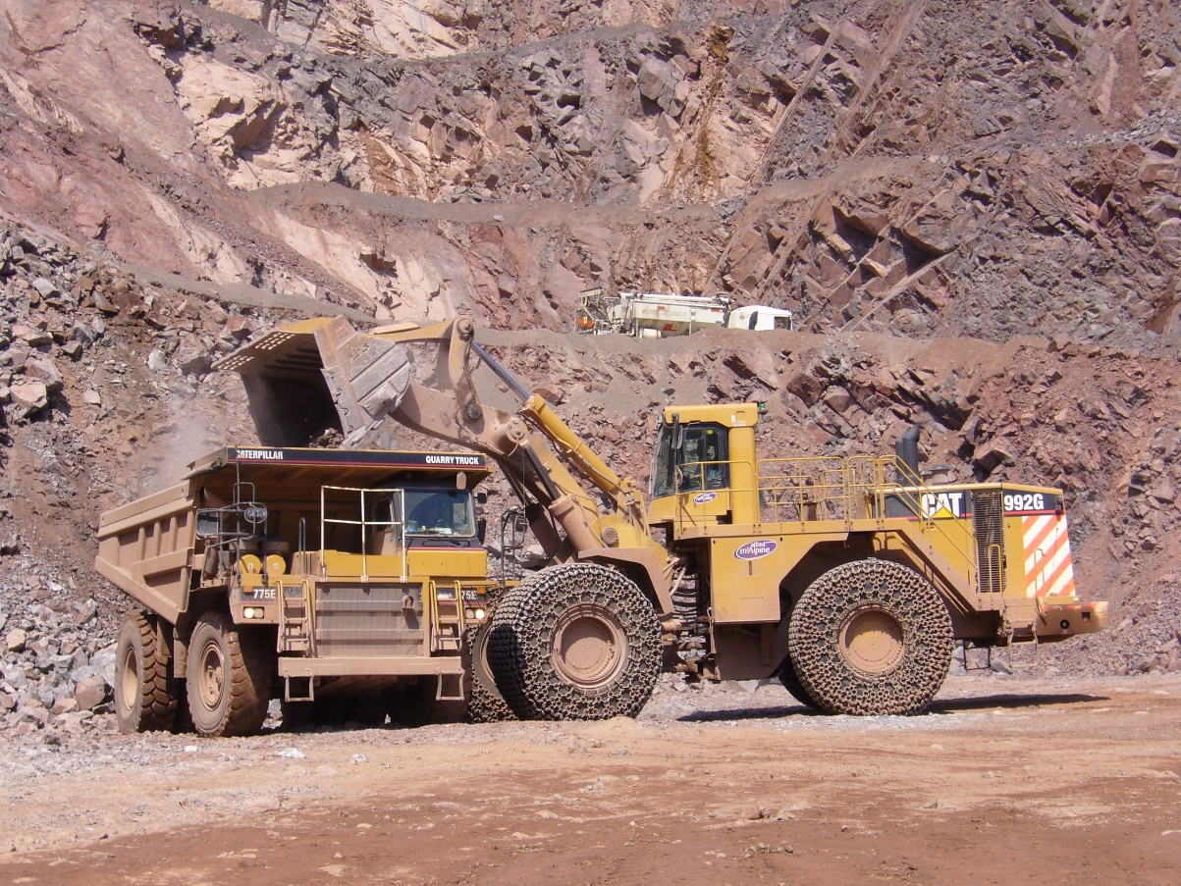

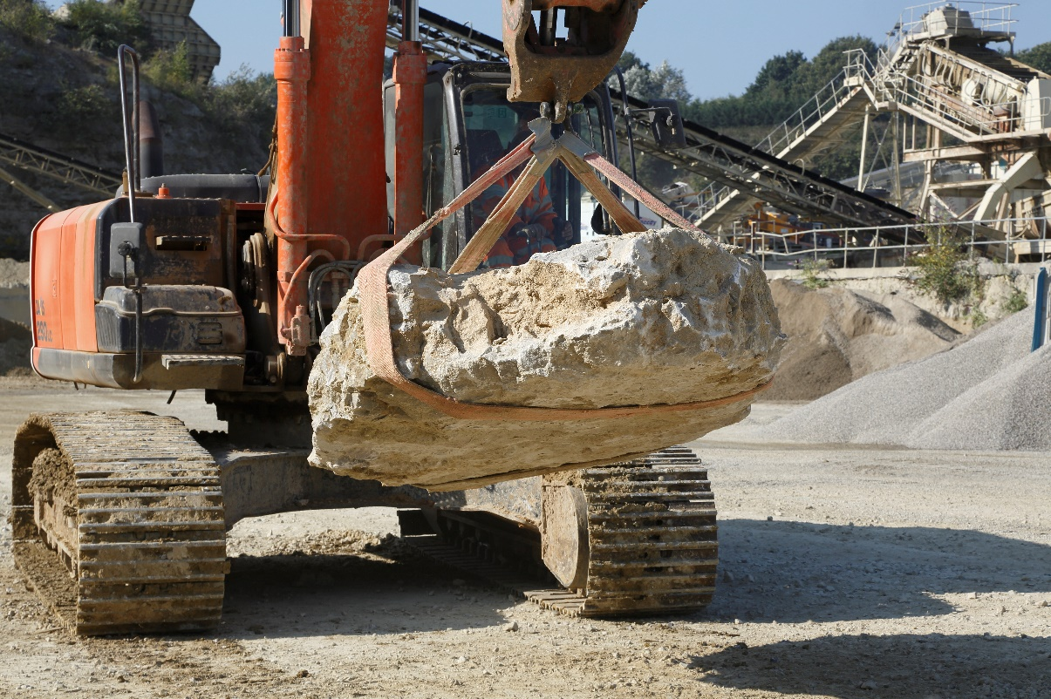
Answers to consultation questions

Q1. What is your name?

Robert McIlveen

Q2. What is your email address?

robert.mcilveen@mineralproducts.org

Q3. Which category in the following list best describes you? If you are replying on behalf of a business or representative organisation, please provide the name of the organisation/sector you represent, where your business(es) is located, and an approximate size/number of staff (where applicable).

Mining and quarrying and mineral products.

The Mineral Products Association (MPA) is the trade association for the aggregates, asphalt, cement, concrete, dimension stone, lime, mortar and silica sand industries. It has a growing membership of 520 companies and is the sectoral voice for mineral products. MPA membership is made up of the vast majority of independent SME quarrying companies throughout the UK, as well as the 9 major international and global companies. It covers 100% of UK cement and lime production, 90% of GB aggregates production, 95% of asphalt and over 70% of ready-mixed concrete and precast concrete production. In 2016, the industry supplied £18 billion worth of materials and services to the Economy. It is also the largest supplier to the construction industry, which had annual output valued at £169 billion in 2018. Industry production represents the largest materials flow in the UK economy

Q4. Would you like your response to be confidential and, if so, why?

No

Q5. Will removing the entitlement to use red diesel in your sector create perverse environmental outcomes? If so, please explain how, providing relevant evidence.

Yes. Two years’ notice with considerable uncertainty is wholly insufficient lead in time for a meaningful response to a change in the tax framework. It will though have an impact on confidence and thus investment, which may have a resultant environmental detriment as companies react by deferring the procurement of more modern and environmentally efficient plant.

Removing the rebate will exacerbate the economic downturn we expect to still be facing in April 2022. Our most recent economic forecast for our sector is that 2020 will see a decline of 24.9% with 2021 recovering by 25.5%, leaving us around 5% behind where we were at the start of 2020. With a total shutdown in early 2020 and a possible round of job losses coming with the end of the Job Retention Scheme, our sector is currently in survival mode and will still be recovering by the time this tax increase is proposed to take effect.

Our members advise us that they are likely to react to this by reducing investment because of the scarcity of cash, and the impact on profitability and confidence. In a survey of our producer members, 96.4% told us it would affect their future investment and recruitment plans with only one respondent (3.5%) thinking it would accelerate investment. Comments from small and medium companies pointed to concern around the impact on businesses’ bottom lines and confidence, and a subsequent impact on ability to invest in new plant or in growing their businesses:

“This will be a very significant cost rise for us in a market that sees downward price pressure continually from subsidised imported materials and now the ravages of the ongoing Coronavirus situation. My feeling is that it will simply see us shrink down to a very small operation.”

“the increased and unprecedented fuel costs associated will heavily reduce to ability to renew plant, such restraints will [h]amper the ability to embrace new and more efficient technology on a regular basis due to having to increase the life span of plant to ensure working payback.”

“We are already fully committed to replacing the mobile plant in the mine with electrically powered plant, but i[t] has not yet developed. The reduction of the rebate will increase cost so reduce internal finance.”

“Increased cost of operating plant via tax benefit removed off Red Diesel will mean we will need to make plant work over longer period to recover increased cost. We will extend our replacement programme and make existing plant last longer.”

“The annual amount that we invest in the future of the business is roughly equal to the additional cost incurred by the removal of the rebate.”

Large UK and multinational businesses in our membership had similar concern around the cost impact, but with more complex renewal strategies had more uncertainty to deal with.

“This would complicate our choices. We will be reluctant to buy new plant operating on obsolete technology; while we will continue to look for alternative solutions, in the short and medium term we will most likely replace less than planned.”

“We would seek to pass on additional costs to the customer. In reality this is unlikely to cover the full impact of the removal of the rebate. We would have to consider reducing other costs e.g. headcount to compensate.”

“We would usually renew equipment with the latest available technology at the time of renewal, however as the equipment manufacturers are still working on advanced technologies we may continue using existing assets past the point of when we would usually renew so that we can buy the very latest viable tech when it comes to market. However that could be some time as the global equipment manufacturers are not rushing their plans to provide replacement equipment just because the UK Quarrying sector requires it”

Our sector uses specialist, extremely heavy and powerful equipment which is likely to be among the last to be replaced by non-diesel options. If the companies do slow their renewal rate for equipment, there would be a detrimental impact on efficiency and thus emissions over time.

With alternatively fuelled equipment for our sector only expected on the market in the medium-to-long term, there is a risk of stranded assets for those companies that buy their own plant and machinery at some point in the transition, and businesses are trying to optimise their equipment in a highly uncertain environment.

The best way to proceed would be a similar process to the engine standards adopted for road vehicles which allow orderly adaptation based on the technologies available. Road fleets have upgraded to Euro 6 in time to meet policies such as the ULEZ in London, and manufacturers have made these engines available in time for fixed, long-term deadlines. But the time scale for this was much longer, over a larger EU-wide market and with more certainty. The exemption for rail is in the same spirit of ensuring alternatives are available, which for rail they already are if the network were electrified. Applying the same logic on a much shorter timescale in one country, excluding agriculture and forestry, two of the largest sectors that use similar equipment, is not going to have the same effect.

Q6. Will removing the entitlement to use red diesel in your sector have an impact on the price of goods and services households and/or voluntary organisations use or pay for over the long-term? If so, please provide relevant evidence.

MPA members were unanimous that they will pass on the cost to consumers in whole or part in our survey. This will feed into the whole economy as the costs of materials for infrastructure, housing, other construction and manufacturing inevitably rise. With HS2 starting construction work and the general increase in Government’s ambition and budget for infrastructure, this cost will be noticeable on public spending, with around 50% of our sector’s production going into public sector or utility projects. Other sectors, such as water treatment which relies on industrial lime and silica sand, will also face increased input costs as our members are forced to pass on the cost.

These costs will indirectly make their way to householders via their tax bills, their mortgages, and the prices they pay for goods and services.

For sectors that are internationally traded, such as cement, lime, concrete products, ball clay, china clay and dimension stone, passing on the price will make them less competitive and increase the risk of carbon leakage.

Q7. How will removing the entitlement to use red diesel in your sector impact your organisation? Please provide details on:

a) Your organisation/sector’s current red diesel consumption and costs, including as a proportion of total costs, and broken down by different uses (i.e. what types of vehicles and machinery)

Across all parts of our industry, MPA members use approximately 200 million litres of red diesel per year. As a proportion of costs this varies widely across products. For example, an SME sand and gravel producer informed us that one of their cheaper products would increase in cost by 17 per cent.

A medium sized contractor told us:

“In order to facilitate our operations we own a large modern plant fleet comprising some 75 pieces of large earthmoving equipment ranging in size from 70 tonne tracked excavators, 40 tonne articulated dump truck, D8 tracked dozers, compactors, graders etc and in a typical year our Red Diesel expenditure is in the order of some £2,500,000 excluding vat.

“Therefore should the Red Diesel rebate be removed it is estimated our fuel bill will increase by some £2,500,000 i.e. doubling our annual expenditure on Red Diesel.”

The company also highlighted that they have long-term framework contracts beyond 2022 and would struggle to recover the added cost.

Some products, for example industrial lime, require a large volume of raw material to be extracted and processed to extract the high quality, high-value product. The cost per tonne of the final product would need to reflect all the additional red diesel costs that were incurred during the extraction and processing.

The types of vehicles and machinery vary, but include very large (e.g. 80-100 tonne) excavators, wheeled loaders, driers and dump trucks. The mobile equipment involved is usually heavier and more powerful than HGVs, which the Government does not expect to be zero-emission by 2050.

b) The operational and financial capacity of your organisation/sector to shift to alternatives to red diesel (specifying what these alternatives are)

There are no viable alternatives currently in the market and we do not expect there to be for several years. None of our members surveyed had found alternatives to the equipment they use. As research commissioned by HM Treasury in 2019 found, mining and quarrying was the sector with the greatest reliance on red diesel, but also that it was keener than average to switch when the equipment was available.

There is financial capacity to invest, as our members do every year when renewing equipment, and once alternative fuelled equipment is available and has met the performance needs of businesses, the new technology will be embraced.

The removal of the rebate will therefore have no impact on our sector’s capacity to buy alternative-fuelled equipment, as there are none available on the market. When the equipment manufacturers are able to supply alternative fuelled equipment, the incentive would change decisions about what to buy but not in itself change the capital allocated to investment.

We are sceptical that there would be any impact on manufacturers’ efforts to provide alternative fuelled equipment at the scale used in our sector.

A similar, regulatory approach to that taken to road vehicle engines, would be much more practical and avoid a very short-term cliff-edge which our members will be unable to avoid. It would also recognise the realistic timescale technology takes to develop.

c) The capacity of your organisation/sector to pass through costs down the supply chain

86% of respondents to our survey indicated they would pass on the additional costs to customers in full and the remaining 14% in part. This includes public and private sector customers in infrastructure, housing and other construction sectors, as well as products as diverse as food packaging, glass and ceramic manufacture, water purification and energy pollution control. There will therefore be an indirect impact spread across much of the economy in terms of cost, on public sector projects such as HS2, and also an impact on competitiveness for internationally traded products such as cement, lime, concrete products and dimension stone.

d) The capacity of your organisation/sector to absorb extra costs

Our latest economic forecast for our sector shows that by 2022 we will still be below where we were in 2019, and will not have fully recovered from the impact of the shutdown due to Coronavirus in 2020. Removing the rebate will add significantly to our sector’s costs, dampening confidence further. This has an impact on investment and recruitment plans.

Q.8 What impact do you expect the removal of red diesel entitlements from most sectors will have on the environment and on air quality? Please provide any evidence you deem relevant.

For our sector it will have no reduced impact in the short to medium term because there is no alternative equipment in the market.

Regarding air quality, the heavy equipment used by our sector in quarries is in rural settings, in common with exempted sectors such as agriculture and forestry. The air quality impact that arises from this equipment is not in urban areas which should be a higher priority for public health.

Similarly on climate change, there will be very limited change in the emissions per tonne associated with production in the UK in the next few years, because there is no alterative equipment available. Businesses already optimise their fuel costs, and thus their emissions. Removing the rebate will raise costs and make UK production less competitive, potentially encouraging production of some products to be offshored. This could move production to less efficient but lower-taxed locations and would increase emissions associated with transport of materials.

Q.9 Do you have any comments on the government’s intention to maintain the entitlement to use red diesel for agriculture (as well as forestry, horticulture and pisciculture), rail and for non-commercial heating (including domestic heating) from April 2022?

The consultation document gives no justification for the agriculture exemption other than it is important to that sector. It is also very important to ours.

The logic of excluding agriculture and forestry but not quarrying is not clear. All are rural industries with similar low impact on air quality. All use similar equipment for part of their operations including earthmoving, cutting, and transporting material around sites. Given the level of subsidy agriculture receives, it seems illogical to exclude them but not similar sectors that do not receive such support.

This exclusion blunts the incentive effect on manufacturers to develop alternative equipment considerably since the largest market for this sort of machinery is agriculture.

The exclusion for rail, especially rail freight, makes more sense. This is important to our sector, as we try to maximise modal shift. Every aggregates train takes 75 lorries off the road, so there is a clear environmental benefit, as there is for other materials moved by rail. Our sector is growing its use of rail freight significantly to improve our environmental performance. One further area for consideration should be rail terminals, which use equipment that is largely diesel powered. These terminals are essential to avoiding unnecessary road haulage so should be included in the rail exemption.

Q.10 The government is interested in gathering further information about the use of red diesel for heating. Please provide relevant evidence of your use of red diesel for this purpose, including on: i) the quantity and cost of the fuel; ii) where in the country the fuel is used (including whether you are on or off the gas grid); and iii) whether you consider that there are any viable alternative energy sources available to you.

No answer

Q.11 Do the announced changes to the tax treatment of red diesel raise any concerns about the application of existing fuel duty reliefs? If so, please provide details on the relief and the issue that you believe will arise.

No answer

Q. 12 Are there any circumstances where, despite nearly two years’ notice, users of red diesel that will be losing their entitlement will have already purchased fuel that they do not expect to have used up by April 2022? If so, please provide evidence to explain why you do not expect to be able to manage your supplies so that you have used up all your red diesel by April 2022.

There are thousands of fuel storage tanks across the sites operated by our industry, some of which may only be filled once per year. Depending on the timing of any announcements on additional sector exemptions, companies could face the risk of buying white diesel and paying duty they do not need to, or red diesel and risk being prosecuted.

It is not practical to refill every tank on the day the tax change comes into force. It is unreasonable and burdensome to require companies to estimate how full their supplies across many tanks will be and what proportion will be used by a fixed date, and attempt to run out their tanks and refill them as close as possible to that date.

Rather, the rebate removal should apply to fuel bought from the wholesaler after the implementation date. This would have no impact on the incentive to buy alternative equipment but would reduce the administrative burden for companies and HMRC.

Q. 13 Do you agree with the government’s suggested approach of mandating RDCOs that switch a fuel tank from red to white diesel in anticipation of the introduction of the tax changes to flush the tank and pump until no trace of marked rebated fuel remains? If you do not, please explain why.

For wholesalers this is burdensome but appropriate, but for customers it should be clarified that they are not expected to flush on-site storage tanks and that enforcement will be reasonable and proportionate. Without this, customers face significant risk and cost for no benefit to the environment.

Q. 14 If you are a fuel supplier, do you foresee any significant difficulties with the proposed arrangements for implementing the changes to the tax treatment of red diesel? If so, please explain why.

No answer

Q.15 Do you agree with the government’s suggested approach of not mandating users of red diesel that will lose their entitlement to flush out the fuel supplies of their vehicles and machinery? If you do not, please explain why.

Yes, customers should not be mandated to flush out on-site storage tanks. But they should also be given reassurance that they do not have to perfectly predict the usage of fuel across all of their tanks. The rebate should be removed for purchase after the date of coming into force rather than use, and enforcement should be proportionate, seeking only to prevent largescale stockpiling.

Q. 16 If you are in a sector that will lose entitlement to use red diesel from April 2022, do you foresee any difficulties with the proposed arrangements for implementing the changes to the tax treatment of red diesel? If so, please explain why.

MPA has records of 3,160 sites in our industry, many of which will have fuel storage tanks for equipment used and the larger ones will have several. It is impossible for companies operating these sites to predict with certainty how much they will use to the point of precision that they could run down stocks for 1st April 2022 perfectly across all sites.

Members have expressed concern at the enforcement by HMRC effectively requiring them to flush out tanks, even if they are not mandated to do so, because of fears of over-precise enforcement.

This problem disappears if the tax is charged on the date of purchase rather than use. While this has some revenue impact for HMRC it would be a significant simplification which would benefit businesses by removing risk and additional costs at a time of economic difficulties. We believe this would be a proportionate response.

No response to the remaining questions

HMT (2019) “Non-road mobile machinery and red diesel call for evidence: summary of responses” p7
MPA Sustainable Development research
DfT (2020) “Decarbonising Transport: setting the Challenge” p40
IFF Research (2019) “Non-agricultural use of red diesel for non-road mobile machinery”; HM Revenue & Customs and HM Treasury Research Report 534
MPA and Rail Freight Group (2019) “Cutting Carbon and Congestion: Rail Freight and Mineral Products working together to build Britain”

